**SCREENSHOTS OF GRAPHS/ OUTPUTS AND ITS DESCRIPTION**

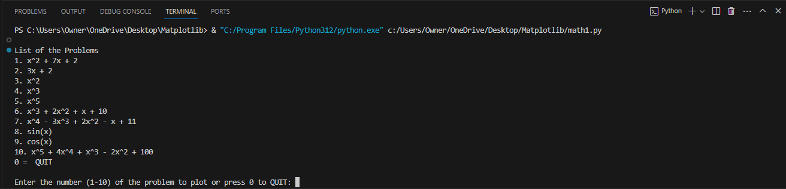

* This will be the format of the source code when you run the program. It will print the list of the problems/functions that the user may enter the number of the problem/function to be plotted. Also, I add a choice 0 to QUIT and stop the program from looping.

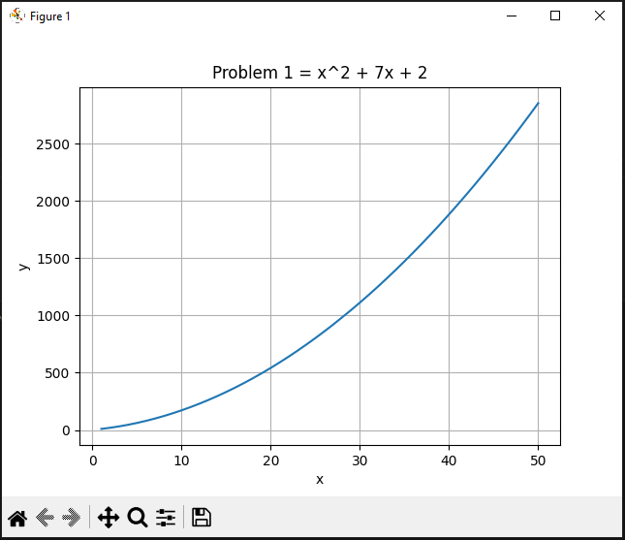

* Graph of the no. 1 (x^2 + 7x + 2) that shows a curve line with (x) inputs between 1 to 50.

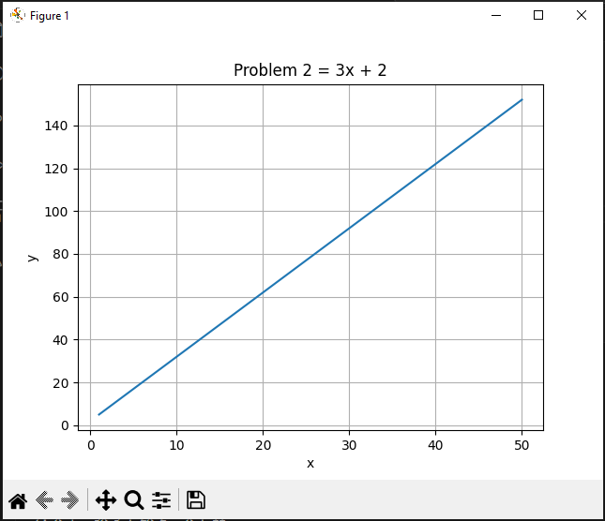

* Graph of the no. 2 (3x + 2) that shows a linear line with (x) inputs between 1 to 50

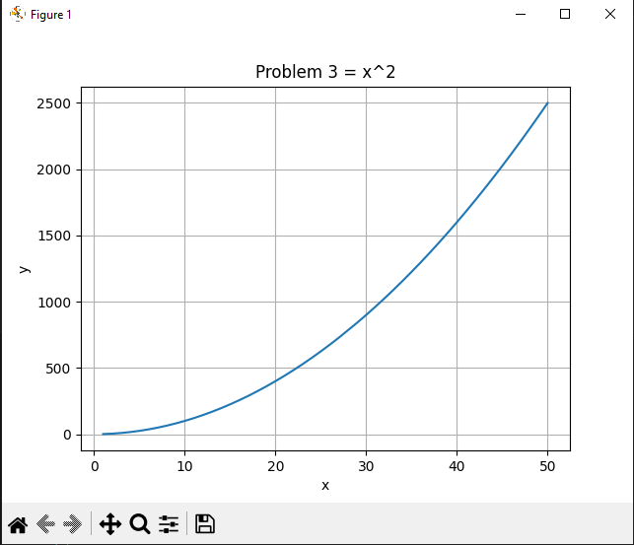

* Graph of the no. 3 (x^2) that shows a curve line with (x) inputs between 1 to 50.

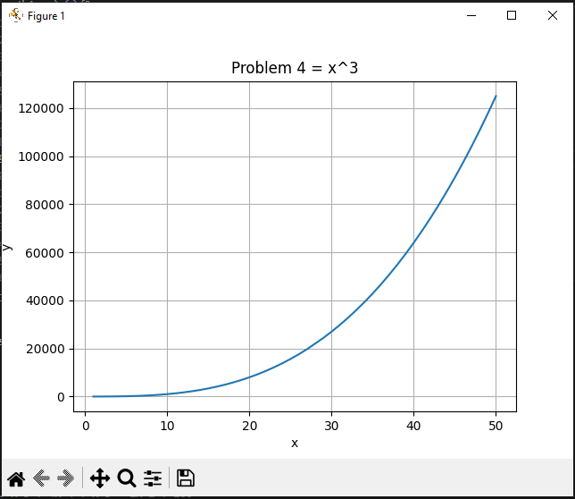

* Graph of the no. 4 (x^3) that shows a curve line with (x) inputs between 1 to 50.

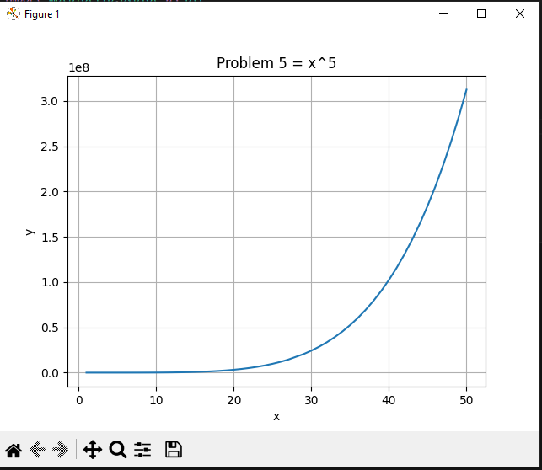

* Graph of the no. 5 (x^5) that shows a curve line with (x) inputs between 1 to 50.

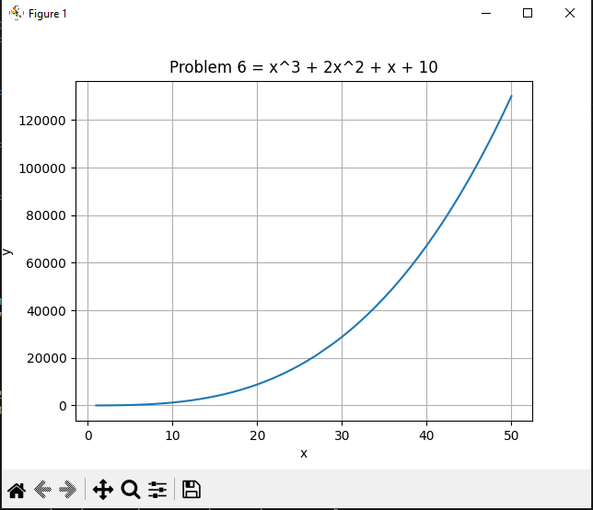

* Graph of the no. 6 (x^3 + 2x^2 + x + 10) that shows a curve line with (x) inputs between 1 to 50.

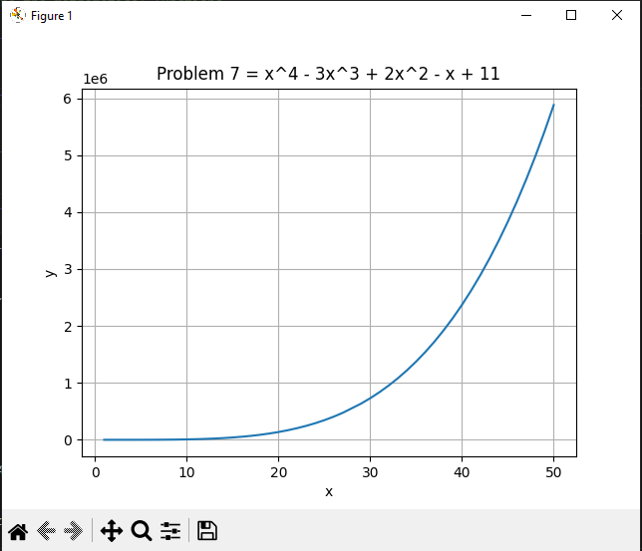

* Graph of the no. 7 (x^4 - 3x^3 + 2x^2 - x + 11) that shows a curve line with (x) inputs between 1 to 50.

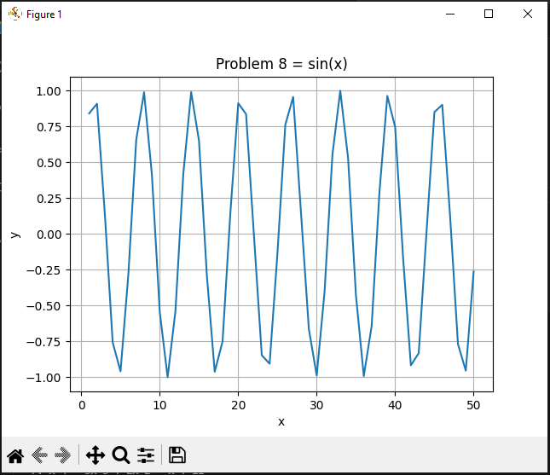

* Graph of the no. 8 (sin (x)) that shows a zigzag line with (x) inputs between 1 to 50.

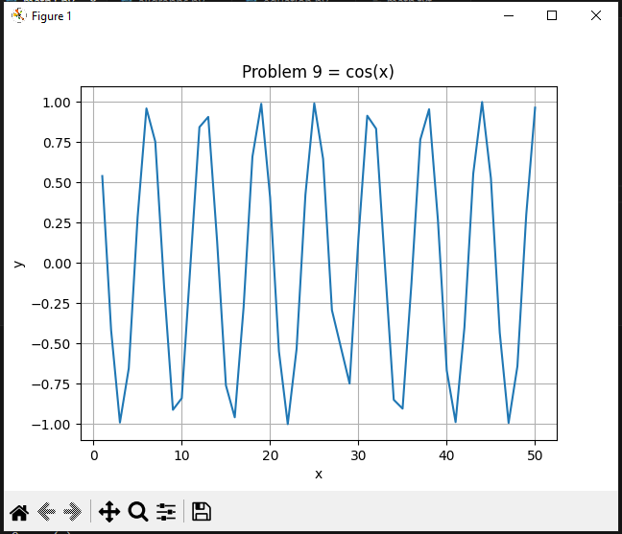

* Graph of the no. 8 (cos (x)) that shows a zigzag line with (x) inputs between 1 to 50.

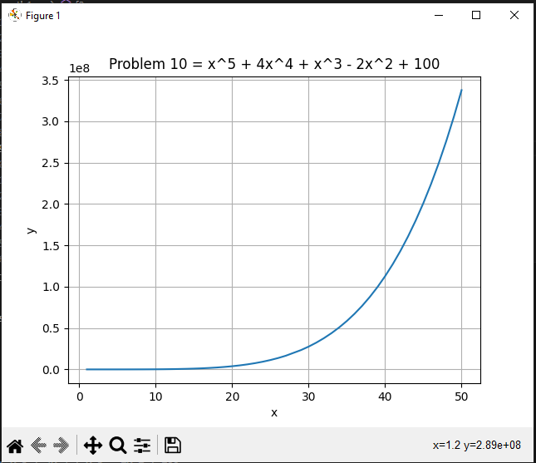

* Graph of the no. 7 (x x^5 + 4x^4 + x^3 - 2x^2 + 100) that shows a curve line with (x) inputs between 1 to 50.

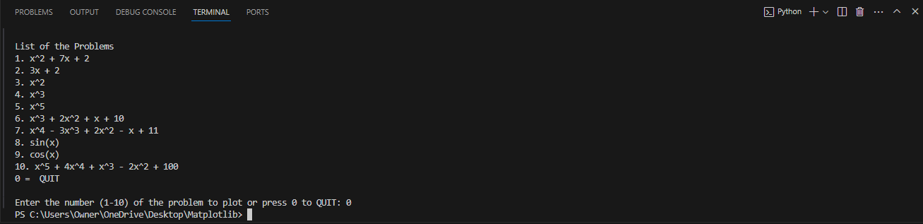

* In this part, when you enter the number 0 it will automatically break the looping of the program.

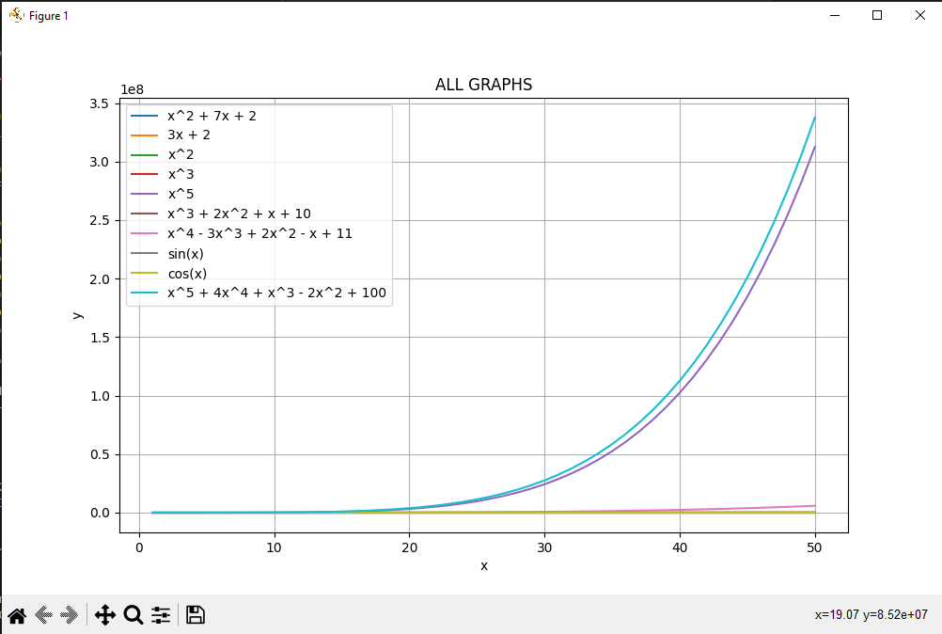

* This figure is all about the combined graphs of problems/functions. It displays curve and linear lines and you can see the corresponding color of lines representing each graph.